**Advance Excel Assignment 2**

**1. What does the dollar($) sign do?**

In Excel, a dollar sign can denote a currency format, but it has another common use: indicating absolute cell references in formulas.

**2. How to Change the Reference from Relative to Absolute (or Mixed)**

By default, a cell reference is a relative reference, which means that the reference is relative to the location of the cell. If, for example, you refer to cell A2 from cell C2, you are actually referring to a cell that is two columns to the left (C minus A)—in the same row (2). When you copy a formula that contains a relative cell reference, that reference in the formula will change.

As an example, if you copy the formula **=B4\*C4** from cell D4 to D5, the formula in D5 adjusts to the right by one column and becomes **=B5\*C5**. If you want to maintain the original cell reference in this example when you copy it, you make the cell reference absolute by preceding the columns (B and C) and row (2) with a dollar sign (**$**). Then, when you copy the formula **=$B$4\*$C$4** from D4 to D5, the formula stays exactly the same.

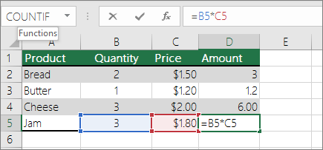

3. Explain the order of operations in excel

In general, Excel's order of operation follows the acronym PEMDAS (Parentheses, Exponents, Multiplication, Division, Addition, Subtraction) but with some customization to handle the formula syntax in a spreadsheet. First, any expressions in parentheses are evaluated.

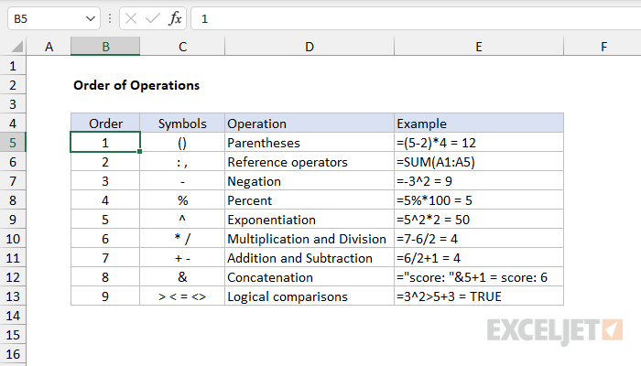

**4. What, according to you, are the top 5 functions in excel and write a basic syntax for any of two?**

IF Function

1.The **IF** function is a premade function in Excel, which returns values based on a **true** or **false** **condition**.

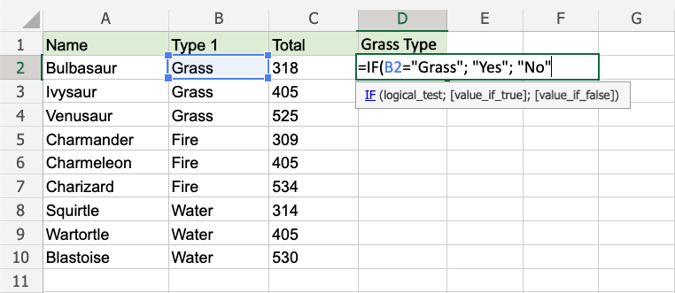

## COUNTIF Function

The **COUNTIF** function is a premade function in Excel, which counts cells as specified.

It is typed =COUNTIF

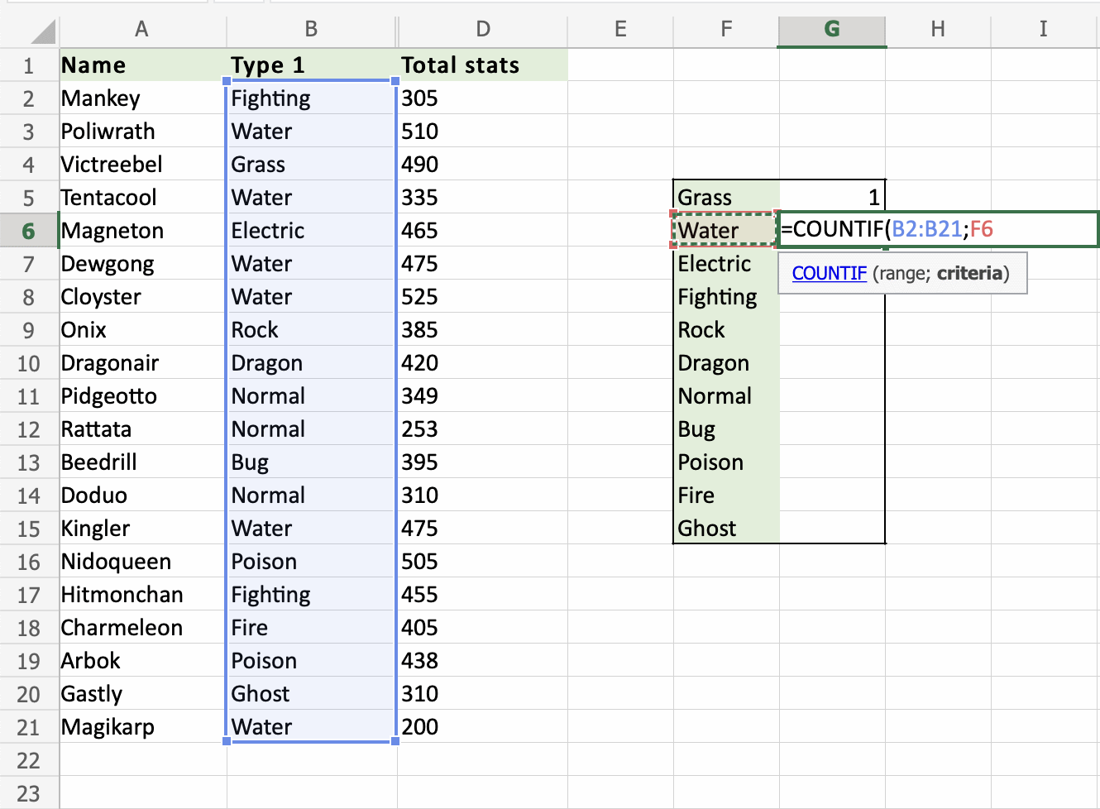

The **SUMIF** function is a premade function in Excel, which calculates the sum of values in a range based on a **true** or **false** **condition**.

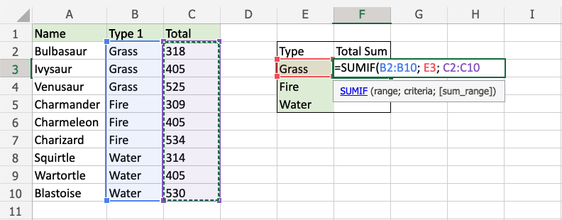

## TRIM Function

The **TRIM** function is premade in Excel and used to remove irregular text spacing and keep single spaces between words.

It is typed =TRIM

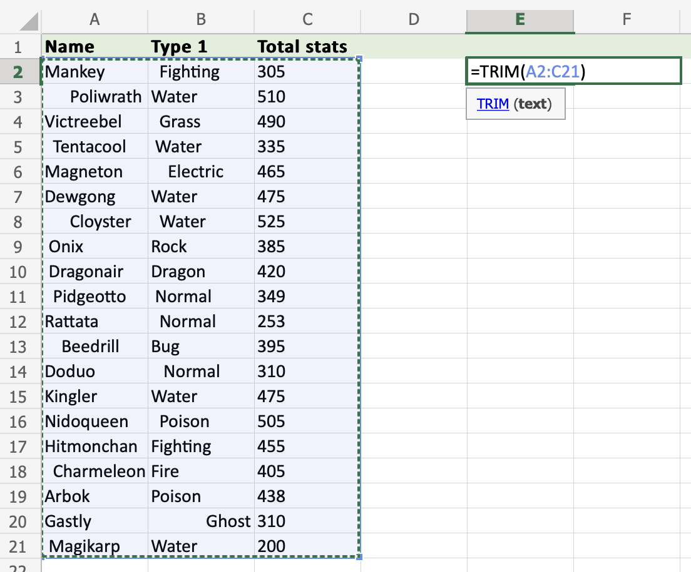

VLOOKUP Function

The **VLOOKUP** function is a premade function in Excel, which allows searches across columns.

It is typed =VLOOKUP and has the following parts:

=VLOOKUP(**lookup\_value**, **table\_array**, **col\_index\_num**, [**range\_lookup**])

**5. When would you use the subtotal function?**

* The SUBTOTAL function is designed for columns of data, or vertical ranges. It is not designed for rows of data, or horizontal ranges. For example, when you subtotal a horizontal range using a function\_num of 101 or greater, such as SUBTOTAL(109,B2:G2), hiding a column does not affect the subtotal. But, hiding a row in a subtotal of a vertical range does affect the subtotal.

**6. What is the syntax of the vlookup function? Explain the terms in it?**

In its simplest form, the VLOOKUP function says: =VLOOKUP(What you want to look up, where you want to look for it, the column number in the range containing the value to return, return an Approximate or Exact match – indicated as 1/TRUE, or 0/FALSE).

=VLOOKUP (B3,B2:E7,2,FALSE)

VLOOKUP looks for Fontana in the first column (column B) in the table_array B2:E7, and returns Olivier from the second column (column C) of the table_array.  False returns an exact match.